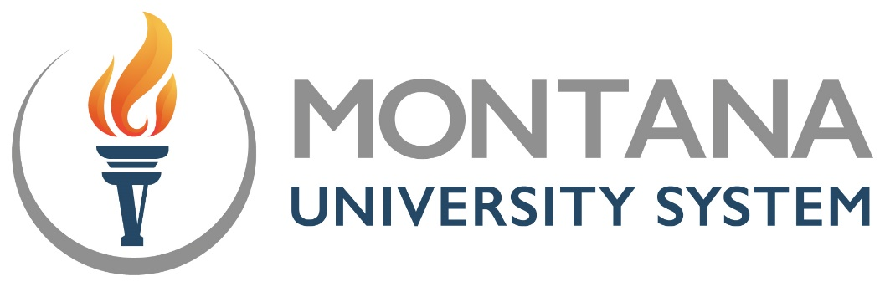

Montana’s Future at Work
Applications due by noon Wednesday, June 5, 2024

The Montana University System seeks promising grant proposals that will deliver responsive CTE outcomes in high-need, short-term credential areas in the community where high school students live.

What is it?
- Montana’s Future at Work is a grant funded by the Dennis and Phyllis Washington Foundation designed with three goals in mind:
- Train 10-15 high school students in a CTE field in the community where they live;
- Market the importance of more training in the field among students, educators, community members and family members
- Promote/Market the CTE field to local and state stakeholders

- The grants will be $30,000-$50,000 in size.
- 4-6 grants will be awarded.
- The awards are for one year with an opportunity for a smaller grant award for a second year.

Who may apply?
- Montana public post-secondary institutions in partnership with at least one accredited Montana high school.

Request for Proposals
Applications must include:

- Must include a creative plan to market/advertise the credential to students, families, educators and other community stakeholders
- A focus on high school students interested in earning one high need short-term credential in a short time in the community where they live
- The high need credential needs to be outlined in the proposal
- A description of how 10-15 students will be recruited to participate and complete the program
- A plan to support these students to a stackable credential before or in concurrence with high school graduation (if the ultimate degree is an AA or AS, the plan must include a plan to ensure completion of a badge or something stackable
- A plan to enroll high school students in credit bearing dual enrollment coursework such as the one credit Career Development & Interpersonal Skills course offered at Miles Community College or any similar course
- Must include a support letter or email from partner high school(s) to supply sufficient numbers of student participants
- Must include a plan to develop and disseminate a 30 second video featuring the credential and it’s need and thus encouraging high school students, their families and others to consider it as a field
- A high need, short-term credential is considered a certificate that can be earned in one or two semesters (in this case while students also matriculate in their high school studies). Ideal grants would support students to completion in the credential area prior to or along with their high school diploma.

  - Potential credential areas could include (please note this is not an exhaustive list of opportunities):
    - Cybersecurity
    - Respiratory therapy
    - Robotics
    - Auto-tech
    - Education
    - Nursing
    - Machining
    - Photonics
    - Dental Assistant

Other Considerations:
How will you partner with industry on your project?
How will you leverage the partnerships with K-12 and with industry to best grow the dialogue and support of this CTE field?
Applications that do not permit roll out and completion in academic year 2024-25 will not be considered.

Funds must be used to meet Montana’s Future at Work program goals and may include:
- Marketing the credential-Marketing can include promotional items such as stickers, magnets, posters, etc. as well as strengthening an online presence for the credential
- Expenses related to convenings for stakeholder groups
- Course, exam and assessment fees including books and supplies for students
2023-24 Grantees may request up to $5,000 to continue their work on their current project by submitting a one-page explanation of fund use as well as planned expenses in the 2024-25 academic year.

To Apply

Complete applications should include no more than ten pages total of narrative, budget and letters of support from partnering institutions including the K-12 school partner(s).
Post-Secondary Lead Applicant Institution/Lead Contact Name/Email/Phone:
Click or tap here to enter text.
Signature:

K-12 School Partner Institution/Lead Contact Name/Email/Phone:
Click or tap here to enter text.
Signature:

*Please add the same information for additional partnering institution.

Please describe your Montana’s Future at Work development and implementation plan. Please include a timeline that matches grant expectations for 2024-25.
How many students will you serve in your program? Describe how you will provide the opportunities for dual enrollment. Describe how you will provide opportunities for credential completion while students are still in high school.
Explain how you and your K-12 partner as well as any other partners (industry or otherwise) will sustain the program once it is started. Include information about sustaining student engagement beyond the initial startup as well as your ability to sustain program delivery.
Include detailed project budget, expenditure timeline and match. The timeline should point to how your overall expenditures will be used over the course of the academic year 2024-25. (This may be added as an attachment.)
Include a 100-word synopsis of your proposal.
Please use the included application form for contact information and signatures. A complete application should include no more than 10 pages total of narrative, a budget, and letters of support from partnering K-12 districts or industry and community partners.

Complete Application Materials are due to amclean@montana.edu by noon on Wednesday, June 5, 2024. Awardees will be announced by mid-June.

