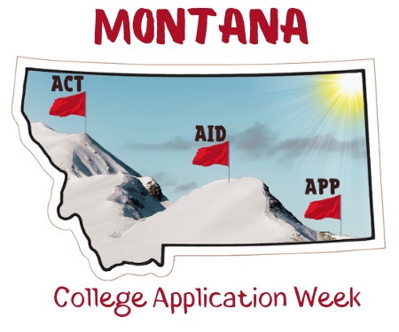
We strongly recommend that you print sign-in sheets with pre-populated student names and birthdates (and a space for them to include the colleges to which they’ve applied), rather than using this form. However, we provide this form in the event you are not able to use pre-printed class lists. These forms should be used to track participation in your event.

Student Sign-in Sheet

Student Name | Birthdate (xx/xx/xxxx) | How many applications did you submit in total? | How many in-state colleges? | How many out-of-state colleges? | Have you applied for your FSA ID yet so that you can complete the FAFSA?

