MONTANA PERKINS V
COMPREHENSIVE LOCAL NEEDS ASSESSMENT
Update Worksheets

2024

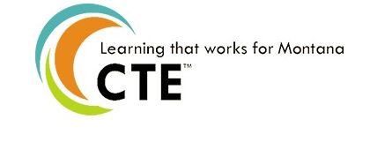

College Name: Click or tap here to enter text.
Authorized Representative: Click or tap here to enter text.
Date of Submission: Click or tap here to enter text.

Process Worksheet 1:

Based on new information and available updated data (including labor market, CTE program, and student), has anything significantly impacted the Identified Needs outlined in the original CLNA in the following areas?

Section of CLNA | Significant Impact on Identified Needs? | Details
1: Student Performance | ☐ Yes ☐ No
2: Size, Scope and Quality | ☐ Yes ☐ No
3: Labor Market Alignment | ☐ Yes ☐ No
4: Progress Toward Implementing CTE Programs/Programs of Study | ☐ Yes ☐ No
5: Recruitment, Retention, and  Training of CTE Faculty and  Staff | ☐ Yes ☐ No
6: Progress Toward Improving Equity and Access | ☐ Yes ☐ No

Process Worksheet 2:

Are the strategies outlined in the original CLNA still relevant? Do any need to be updated? If so, please provide updated strategies and relevant activities.

Section of CLNA | Strategies Still Relevant? | Updated activities and strategies if available
1: Student Performance | ☐ Yes ☐ No
2: Size, Scope and Quality | ☐ Yes ☐ No
3: Labor Market Alignment | ☐ Yes ☐ No
4: Progress Toward Implementing CTE Programs/Programs of Study | ☐ Yes ☐ No
5: Recruitment, Retention, and  Training of CTE Faculty and  Staff | ☐ Yes ☐ No
6: Progress Toward Improving Equity and Access | ☐ Yes ☐ No

